Name: |  | Date:
Landform Dictionary Checklist
Word | Has Definition | Is Illustrated | Spelled Correctly | Uses it in a Sentence
Landform
Mountain
River
Lake
Valley
Coast
Harbor
Use the Language Rubric to assess students’ level of comprehension using a dictionary or other sources (books, photos, models made for performance task).
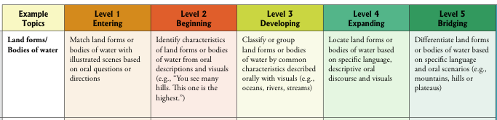
Student Level: ____________
Teacher Observations/Notes:

